Jaguar Strength & Speed Camp
Westmoore Athletic Development
Develop Strength, Power, Speed, Agility, & Explosiveness
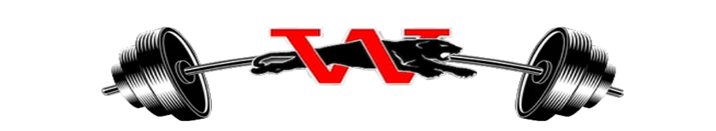
Who: Any Male or Female – Grades (9-12)
Location: Westmoore Weight Room (Door 28)
Time: Monday, Tuesday & Thursday
Session 1: Boys 10:00 am – 11:00 am
Session 2: Girls 11:00 am – 12:00 am
When: June Session (June 10th – June 28th)
July Session (July 8th – August 2nd)
Cost: $100
WRESTLING ONLY (Meet in Wrestling Room Door 22)
Who: Any Male or Female – Grades (6-12)
Session 3: Boys/Girls 6:00 PM - 7:30 PM
When: June Session (June 10th – June 28th)
July Session (July 8th – August 2nd)
Cost: $100
*Sign up before May 10th and receive a T-Shirt
*Payments due by May 15th
Payment Method – Cash or Go to My Payments Plus on the Westmoore Webpage
Contact Information: Coach Cook or Coach Finn
*Please fill out and turn in if paying in CASH*
Name:________________________ Grade:____________________ Sport:_____________________
Parent Phone Number: _________________ T-Shirt Size___________

