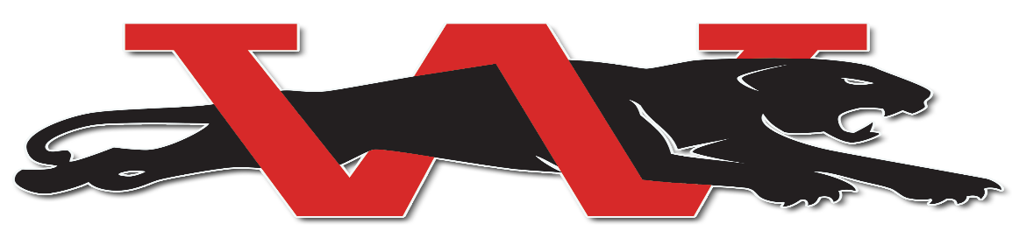

Parents and Athletes,

I would like to take this opportunity to invite you to join our wrestling team for the 2019-2020 wrestling season. Many people wrestle for several different reasons; some want to be wrestling state champs, some want to be on a winning team, but most just want to wrestle to become better athletes and better football players. Enclosed in this packet you will find important paper work in regards to wrestling. Please fill out the paperwork and you can either bring back to parent meeting or you can turn in at our annual weight certification.

Check out some of these quotes and NFL football players who wrestled in high school.

“Wrestlers make coaching football easy. They have balance, coordination, and as a coaching staff, we know they’re tough.”
–Tom Osborne, College Hall of Fame football Coach-University of Nebraska
“I love wrestlers. They are tough and they make great football players.”
– Mike Stoops, National Championship Football Coach-University of Oklahoma
“I would have all of my offensive linemen wrestle if I could.”
-John Madden, Hall of Fame football coach
“I draft wrestlers because they are tough. I have never had a problem with a wrestler.”
–Joe Gibbs, Hall of Fame football coach.
Below are just a few famous NFL football players who wrestled in high school.

Ray Lewis (2X Florida State Champ)
Lorenzo Neal (NCAA Champ)
Kelly Gregg (3X Oklahoma State Champ)
Bo Jackson
Jim Plunkett
Warren Sapp (State Champ)
Tim Burroughs (Oklahoma State Champ)
Jim Thorpe
The list goes on and on of great football players /athletes who wrestled.

Any coach will tell you that the key to being successful is to stay competitive. When searching for a winter activity for your athlete please give wrestling a chance. Wrestling will help your child’s over all athletic ability. Your child will become faster, stronger, quicker, and more importantly more confident. One more thing, your child will never be forced or made to lose weight. We want our athletes happy and healthy.

Coach Brad Dick, Coach Chris Finn and Coach John Jacob Finn, will be coaching our Junior High Wrestling team this season. Like last season our Junior High Wrestling teams will be practicing at Brink Junior High (After the High School Football Season is over). Moore West athletes will shuttle to Brink. Until the high school football season is over and once junior high football is over and athletes are released to their next sport, all Junior High wrestlers (Brink and Moore West) will shuttle to the high school for wrestling practice. After the high school football season is over junior high practices will return to Brink. Our Brink Wrestling room, over the off season, has been totally redone with new wall mats and practice mats. It is one of the nicest Junior High Wrestling rooms in the State!

We do have boxes of wrestling shoes that athletes can borrow for the season.

To answer all questions, we will have a parent meeting Thursday, Sept. 19th at 6:30 p.m. in the Westmoore High School cafeteria commons. Please bring your packet of paperwork to the meeting

When looking for a winter activity for your athlete, please give wrestling some thought. Feel free to call or email with any questions.

Will Evans
Head Wrestling Coach
Westmoore High School
Cell: 918 549 8443
Email: willevans@mooreschools.com

