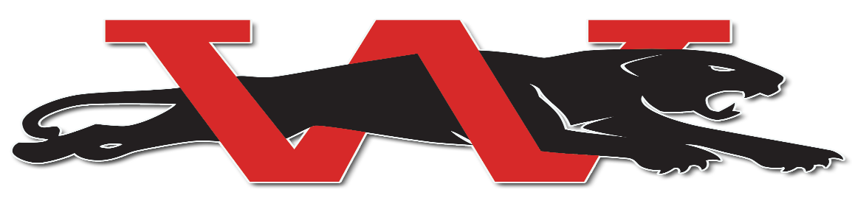
Westmoore Wrestling 2021-2022 Junior High Varsity (RED)
 | Event | Time | Location
Nov. 6 | Edmond North Open | 9:00am | Edmond North High School
Nov. 9 | Wrestle a Thon (HS/JH/Elementary) | 6:00pm | Westmoore High School
Nov 13 | Westmoore Open | 9:00am | Westmoore High School
Nov. 20 | Southmoore Open (HS/JH) | 9:00am | Southmoore High School
Nov. 24 | Tuttle Pre-Turkey Open | 9:00am | Tuttle Middle School
Dec. 3 / 4 | Shawnee JH Duals (JH and JVJV) and JH Women | TBA | Shawnee MS Gym
Dec. 7 | Edmond Memorial Dual (HS/HSJV/JH/JHJV) | 6pm | Westmoore High School
Dec. 9 | Norman North Dual (HS/HSJV; JH/JHJV) | 6:00pm | Westmoore High School
Jan. 4 | Edmond North Dual (HS/HSJV; JH/JHJV) | 6:00pm | Edmond North High School
Jan. 6 | Yukon Dual (HS/HSJV/JH/JHJV) | 6pm | Westmoore High School
Jan. 13 | Moore City Dual HS and JH Varsity | TBA | Southmoore HS
Jan 14/15 | Perry Junior High Invitational | 9am | Perry High School
Jan 18 | Piedmont Dual HS/JH | 6pm | TBA
Jan. 20 | Junior High District Tri  (Westmoore, Norman, Edmond Santa Fe) | TBA | Westmoore Jag Arena
Jan. 25 | Deer Creek Dual |  | Deer Creek High School
Jan. 28/29 | Edmond Junior High Tournament (JH) | 12:00 | Edmond North High School
Feb. 1 | Sapulpa Dual (HS/HSJV/JH/JHJV) | 6:00pm | Westmoore High School
Feb. 4/5 | Junior High All State | 10:00am | OKC Fairgrounds

