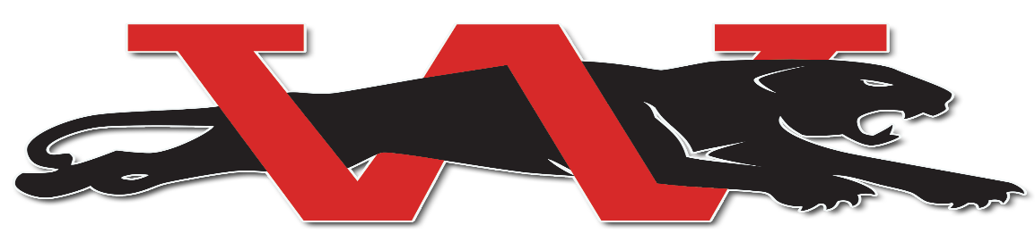
Westmoore Wrestling 2021-2022 JH (SILVER) Schedule
 | Event | Time | Location
Nov. 6 | Edmond North Open | 9:00am | Edmond North High School
Nov. 9 | Wrestle a Thon (HS/JH/Elementary) | 6:00pm | Westmoore High School
Nov 13 | Westmoore Open | 9am | Westmoore High School
Nov. 16 | Del City JH Preview | 5:00pm | Del City Middle School
Nov. 18 | Jaguar Junior High Preview | 6:00pm | Westmoore High School
Nov. 20 | Southmoore Open (HS/JH) | 9:00am | Southmoore High School
Nov. 24 | Tuttle Pre-Turkey Open | 9:00am | Tuttle Middle School
Nov. 30 | Guthrie Tri HSJV/JHJV | 6pm | Westmoore High School
Dec. 7 | Edmond Memorial Dual (HS/HSJV/JH/JHJV) | 6pm | Westmoore High School
Dec. 9 | Norman North Dual (HS/HSJV; JH/JHJV) | 6:00pm | Westmoore High School
Dec. 10/11 | Del City MS Dual Tournament (6,7,8) | TBA | Del City High School
Dec. 18 | Westmoore JV Tournament (HS & JH) | 10:00am | Westmoore High School
Jan. 4 | Edmond North Dual (HS/HSJV; JH/JHJV) | 6:00pm | Edmond North High School
Jan. 6 | Yukon Dual (HS/HSJV/JH/JHJV) | 6pm | Westmoore High School
Jan. 7 | Edmond Santa Fe JH JV Tournament | TBA | Edmond Santa Fe High School
Jan 11 | Guthrie Tri HSJV/JHJV | 6:00pm | Guthrie High School
Jan. 25 | Deer Creek Dual | 6:00pm | Deer Creek High School
Feb. 1 | Sapulpa Dual (HS/HSJV/JH/JHJV) | 6:00pm | Westmoore High School
Feb. 4/5 | Junior High All State | 10:00am | OKC Fairgrounds

